**WIGGINTON PARISH COUNCIL** WARDEN UPDATE: **JULY/AUGUST/SEPT 2023**

|  |  |
| --- | --- |
| **AREA** | **SPORTS FIELD** |
| **TO CHECK** | Gym/Sports equipment, Children’s playground, Car Park, Trees & vegetation, Safety Information, Fencing, Gates, Wooden bollards, Benches, Picnic Tables, Grass height, General ground conditions, Litter and Dog waste bags. |
| **INSPECTION DATES** | 17/07, 24/07, 31/07, 7/08, 14/08, 21/08, 28/08, 4/09, 11/09 |
| **ISSUES TO REPORT** | 1. Weekly litter picking was completed. 2. Playground apparatus was seen in good order. As highlighted in the recent annual inspection report, the depth of the loose fill surface is below the depth specified in BS EN 1176. WPC my wish to replenish loose fill or seek a longer-term solution. 3. Fitness/gym equipment was seen in working order (please see outstanding items below). 4. Dog poo bag dispensers were replenished on a weekly basis. 5. Grass is meeting the height stipulated within the mowing specification. 6. All furniture was viewed in sound order. 7. Both football goalmouths have fully recovered following the recent renovation works. An excellent coverage of sward is now visible, ensuring the pitch is ready for the football season (Photo 1). 8. Broken sign on the emergency gates near the village shop. WPC may wish to order a replacement (Photo 2).   **Outstanding items**:   * A user information label is missing on the Twist and Step Gym station. * Branches affecting the crossover fitness machine need to be cut back. * Boundary hedge is overgrown, top, and sides, ideally to be cut in November (Photos 3 & 4). * Abandoned motor vehicle is still awaiting collection from the car park. DBC are scheduling removal following more appeals by WPC. |

|  |  |
| --- | --- |
| **AREA** | **RECREATION GROUND** |
| **TO CHECK** | Fencing, Benches/seats, Trees & vegetation, Grass height, Car Park, Litter & Dog waste bins. |
| **INSPECTION DATES** | 17/07, 24/07, 31/07, 7/08, 14/08, 21/08, 28/08, 4/09, 11/09 |
| **ISSUES TO REPORT** | 1. Weekly litter picking was completed. 2. Benches were in place and in good order. 3. Dog poo bag dispensers were replenished as needed. 4. Grass height is meeting the mowing specification. 5. A wooden fence post is badly decayed and in danger of toppling over (Photos 5 and 6). 6. A large cannister of Nitrous Oxide (laughing gas) was found in undergrowth on the 14th of August (Photo 7). WPC notified.   **Outstanding items:**   * Re-fastening of wooden benches to the ground. * Removal of a protruding metal object adjacent to the Fieldway entrance.   (Clerk has chased up outstanding items). |

|  |  |
| --- | --- |
| **AREA** | **HIGHWAY’S, PUBLIC FOOTPATHS & DITCHES** |
| **TO CHECK** | Surfaces, Pedestrian routes, Signage inc. finger post, Bench (Oddy Hill), Drainage, Grit bins, Litter, Bollards, Footpaths/Kissing gates, Notice boards, Defibrillator |
| **DATES** | 17/07, 24/07, 31/07, 7/08, 14/08, 21/08, 28/08, 4/09, 11/09 |
| **ISSUES TO REPORT** | 1. The AED was in place. Battery is currently 66% full. 2. Weekly litter pick was conducted within the village centre. 3. Three new street nameplates, to replace damaged nameplates, have been installed by DBC: two in Hemp Lane and one in Chesham Road. Ref no: 761319 (Photos 8,9, and 10). 4. Overhanging branches are preventing pedestrians from using the pavement at the bottom of Oddy Hill (near the roundabout). Pedestrians have little option but to enter the road. Moreover, it is difficult to see approaching vehicles. HCC notified. Ref No: 401003579173. 5. Following a request by WPC, a homeowner has cut back a hedge previously hindering pedestrian access (Photo 11). 6. Temporary traffic signs left on the verge by Crawley’s Lane have been collected by HCC. Ref No: 401003579169. 7. Badly faded lines at the Wick Road/Chesham Road junction. It has been observed that vehicle drivers, unfamiliar with the road layout, have failed to stop at the junction (Photo 12). Ref No: 401003639185. 8. An important open/overflow drain, opposite Osborne Way, has recently been filled in during vegetation clearance works (Photo 13). HCC notified. Ref No: 401003639247. Reinstatement works are planned by HCC Highways. 9. Road surface patch repairs have been completed in Osborne Way and The Firs making for a smoother ride for road users (Photos 14 and 15). 10. Circa fifteen metres of uneven road has been resurfaced at the bottom of Hemp Lane near the A41 Bridge Photo 16). Nearby, further sections of rough road have been marked out for repair.   **Outstanding items (HCC and DBC).**  Blocked Drains (HCC)   * Blocked drain opposite 6, Latimer Cottage, Wigginton Bottom. Ref No: 401002236268. * Blocked drain by the Wick Road/Chesham Road junction (Ref No: 401003246287). * Blocked drain in Chesham Road, facing the Sports Field main entrance (Ref No: 401003246288). * Blocked drain near the village hall was reported to HCC. Ref No: 401003377847. * Blocked drain in Hemp Lane opposite property Kirkdale. Ref No: 401003596160   HCC have added the above blocked drains to the annual drain unblocking schedule. |

**PHOTOGRAPHS**

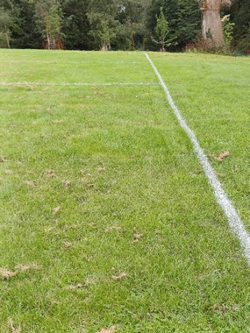 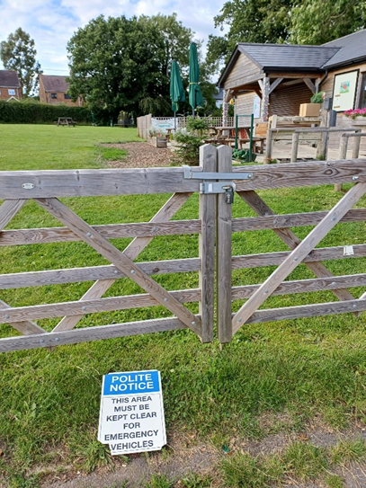 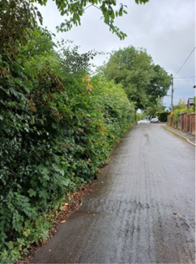

1

3

2

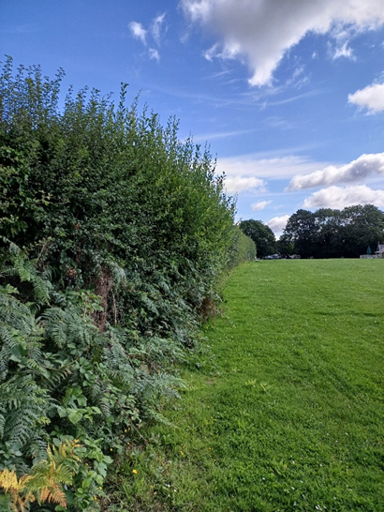

6

5



4

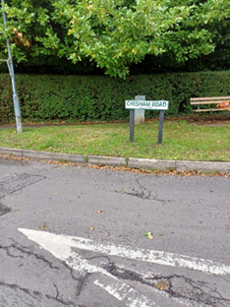 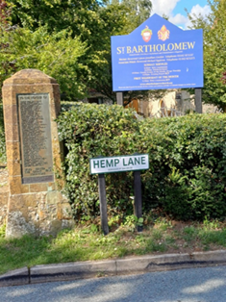

9

8

7

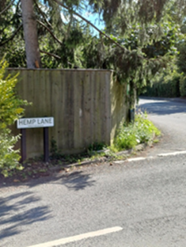 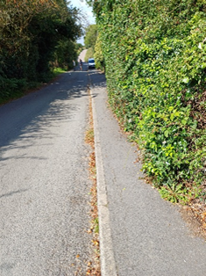 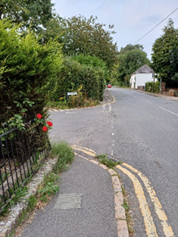

12

11

10

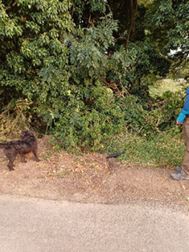 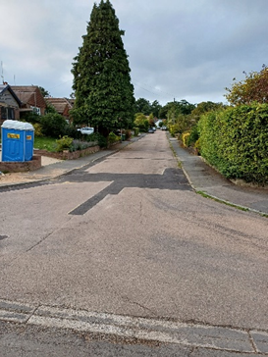 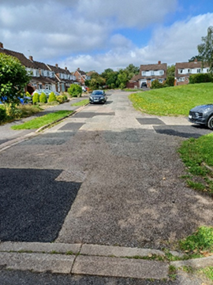

15

14

13

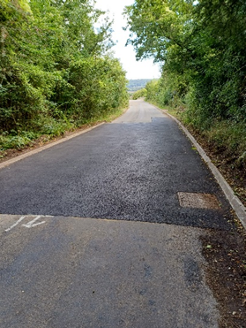

16